**Project Portfolio**

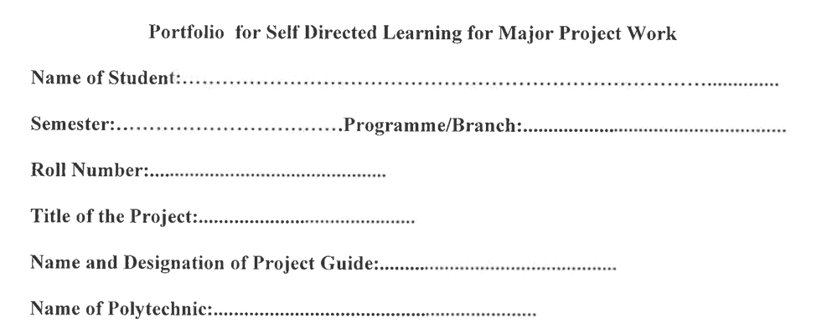

**After Finalization of Project Topic & Formation of Project Team**

1. How many alternatives we thought before finalizing the project topic?

The topic of our project is “Monitoring user web sessions”. We are trying to develop a software to track all the user web sessions. The alternatives we thought before finalizing the project topic was software to block websites and a software to predict user web behaviour.

1. Did we consider all the technical fields related to branch of our diploma programme?

Yes, we considered all the technical fields related to branch of our diploma programme.

1. Why we found present project topic as most appropriate?

We wanted to get rid of the manual work of checking browser history and whether or not a student or employee is doing something unproductive during the work hours.

1. Whether all the group members agreed on the present project topic? If not? What were the reasons of their disagreement?

Yes, all of my group members agreed on the present project topic.

1. Whether the procedure followed in assessing alternatives and finalizing the project topic was correct? If not then discuss the reasons.

I almost tried my best and did follow the procedure for finding the project topic as instructed by our mentors. Hence, the procedure followed in assessing alternatives and finalizing the project topic was correct.

1. What were the limitations in other alternatives of project topic?

We had two other alternative topics.

1. Software to Block websites

2. Software to Predict user web behaviour

In a software to block websites, the websites can still be accessed using a virtual proxy network so there is no guarantee that the blocked sites will not be accessed by the user.

In a software to predict user web behaviour, the algorithms are way too complex to understand and implement.

1. How we formed our team?

For a perfect team, it is important to have a person with good technical skills, a person with good presentation and documentation skills and a person with good management skills. Each one of the team members possess one of these skills.

1. Whether we faced any problem in forming the team? If yes, then what was the problem and how was it resolved?

No, we did not face any problem in forming the team.

1. Am I the leader of our project team? If yes, then why was I chosen? If not, why I could not become the project team leader?

Yes, I am the leader of our project team. I was chosen because I have good technical and presentation, communication skills.

1. Do I feel that present team leader is the best choice available in the group? If yes, then why? If not then why?

Yes, I feel that the present team leader is the best choice available in the group.

1. According to me who should be the leader of the team and why?

According to me, I should be the leader of the team because I have good technical skills and presentation, communication skills and I am chosen as the team leader.

1. Can we achieve the targets set in the project work within the time and cost limits?

Since we have plenty of time, and a great time, according to me we achieve the targets set in the project work within the time and cost limits.

1. What are my good/bad sharable experiences while working with my team which provoked me to think? What I learned from these experiences?

I have had a great time and a learning experience in preparing this project with my teammates. I was provoked to think about how different projects work while searching for references, I learned a lot about web sessions from this experience.

1. Any other reflection which I would like to write about formation of team and finalization of project title, if any?

No, there is no other reflection which I would like to write about formation of team and finalization of project title.

**After Finalization of Project Proposal**

1. Which activities are having maximum risk and uncertainty in our project plan?

Activities such as Analysis, Design, Implementation, Testing are having maximum risk and uncertainty in our project plan.

1. What are most important activities in our project plan?

Designing, Implementation and Testing of the project are the most important activities in our project plan.

1. Is work distribution is equal project group members? If not? What are the reasons? How we can improve work distribution?

Yes, The work among each group member is distributed properly each and every group members are assigned with various task and assignment based on the project. For the purpose that there should not be any burden on a particular individual.

1. Is it possible to complete the project in given time? If not then what are the reasons for it? How can we ensure that project is completed within time?

Yes, It is possible to complete the project within the time because the project tasks are distributed equally among the group member so that the group member can perform different task at a time and project can be completed easily on time. There is also plenty of time.

1. What extra care and precaution should be taken in executing the activities of high risk and uncertainty? If possible, how such risks and uncertainties can be reduced?

Yes, It is possible to complete the project within the time because the project tasks are distributed equally among the group member so that the group member can perform different task at a time and project can be completed easily on time.

1. Can we reduce the total cost associated with the project? If yes, then describe the ways.

The total cost is already not much so there is no need to reduce the cost.

1. For which activities of our project plan, arrangement of resources is not easy and convenient?

Actually there is not any activity that we cannot arrange any resource there are various materials, guidelines, article, IEEE papers related to the project which we can find on the internet.

1. Did we make enough provisions of extra time/expenditure etc. to carry out such activities?

Yes, we made enough provision of extra time to find IEEE and journal papers for the review.

1. Did we make enough provisions for time delays in our project activity? In which activities there are more chances of delay?

Yes, we made enough provisions for time delays in our project activity. In implementation, there is more chances of delay.

1. In our project schedule, which are the days of more expenditure? What provisions we have made for availability and management of cash?

Design and implementation have days of more expenditure. We have made plans thinking about each possible consequence and carried out project analysis and already saved up cash for the project.

1. Any other reflection which I would like to write about project planning?

No, there is no other reflection which I would like to write about project planning.